//FOR12

#include<iostream>

using namespace std;

int main()

{

setlocale(LC_ALL, "Ru");

int n;

float a = 1.0, b = 1.1;

cin >> n;

for (float i = 1; i <= n; i++)

{

a = (float)a * b;

b += 0.1;

}

cout << a;

}

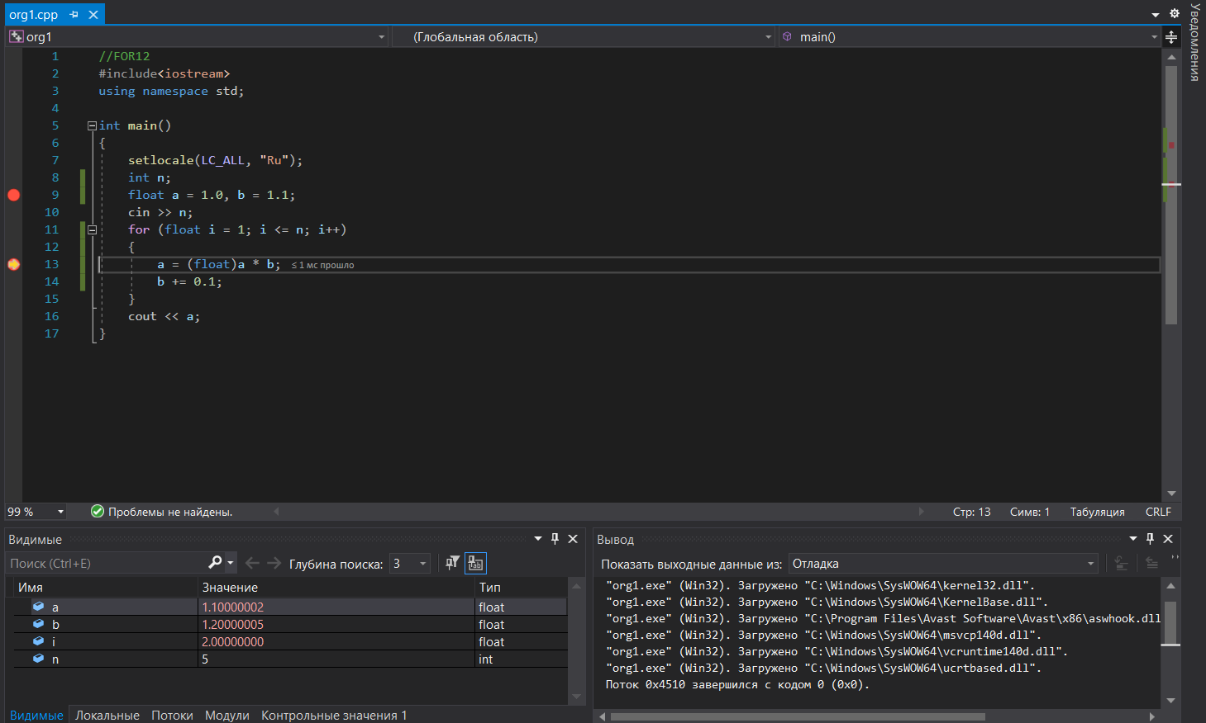

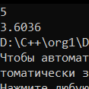

//FOR14

#include<iostream>

using namespace std;

int main()

{

setlocale(LC_ALL, "Ru");

int n, a = 0;

cin >> n;

for (int i = 1; i <= n; i++)

{

a += 2 * i - 1;

cout << a << endl;

}

}

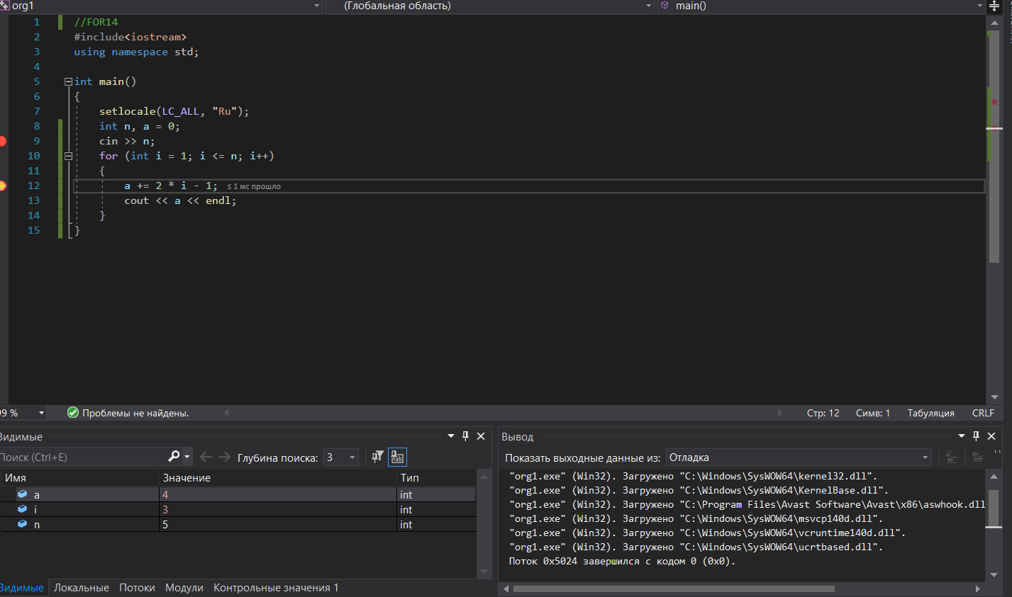

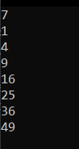

//FOR16

#include<iostream>

#include<math.h>

using namespace std;

int main()

{

setlocale(LC_ALL, "Ru");

int n;

float a;

cout << "Введите А" << endl;

cin >> a;

cout << "Введите N" << endl;

cin >> n;

for (int i = 1; i <= n; i++)

{

cout << "А в степени " << i << " равна " << pow(a, i) << endl;

}

}

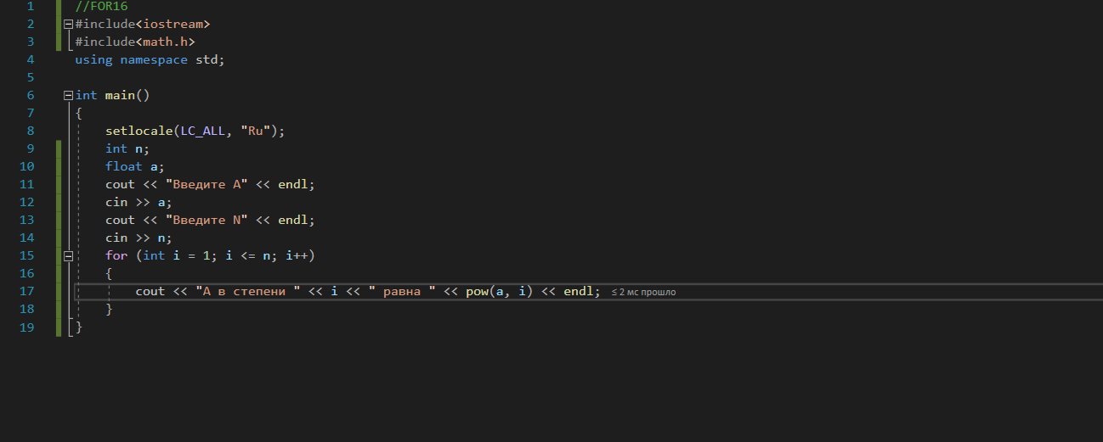

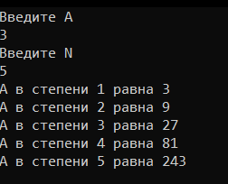

//FOR18

#include<iostream>

#include<math.h>

using namespace std;

int main()

{

setlocale(LC_ALL, "Ru");

int n;

float a, s = 0.0;

cout << "Введите А ";

cin >> a;

cout << "Введите N ";

cin >> n;

for (int i = 0; i < n; i++)

{

s += pow(-1, i) * pow(a, i);

}

cout << s;

}

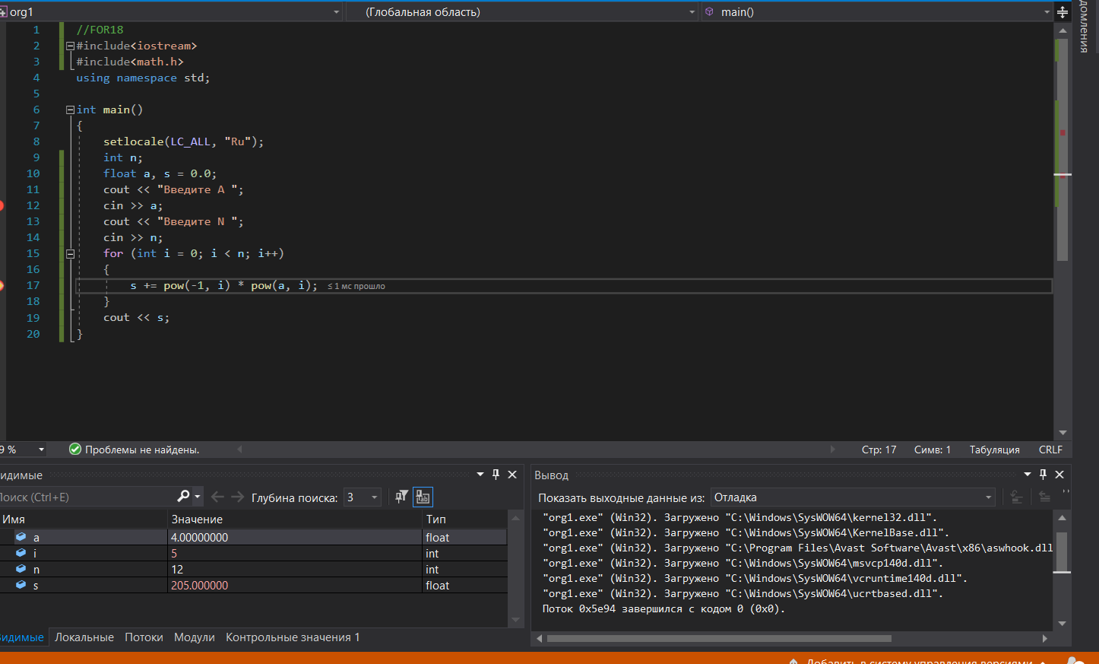

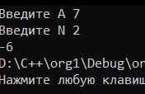

//FOR20

#include<iostream>

#include<math.h>

using namespace std;

int main()

{

setlocale(LC_ALL, "Ru");

float a, b, n, s = 0.0;

cout << "Введите N ";

cin >> n;

for (int i = 1; i <= n; i++)

{

b = 1.0;

for (int g = 1; g <= i; g++)

{

b = b * g;

}

s = s + b;

}

cout << s;

}

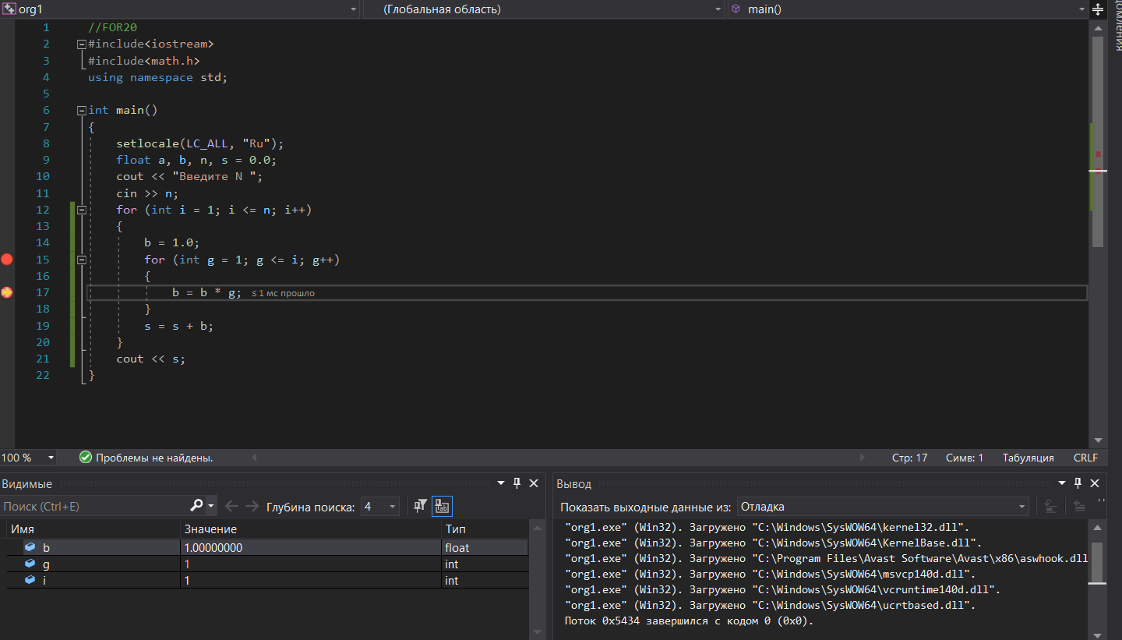



//FOR22

#include<iostream>

#include<math.h>

using namespace std;

int main()

{

setlocale(LC_ALL, "Ru");

float x, s = 0.0;

int n, b = 1.0;

cout << "Введите N ";

cin >> n;

cout << "Введите X ";

cin >> x;

for (int i = 0; i <= n; i++)

{

for (int g = 1; g <= i; g++)

{

b = b * g;

}

s += (float)pow(x, i) / b;

}

cout << s;

}

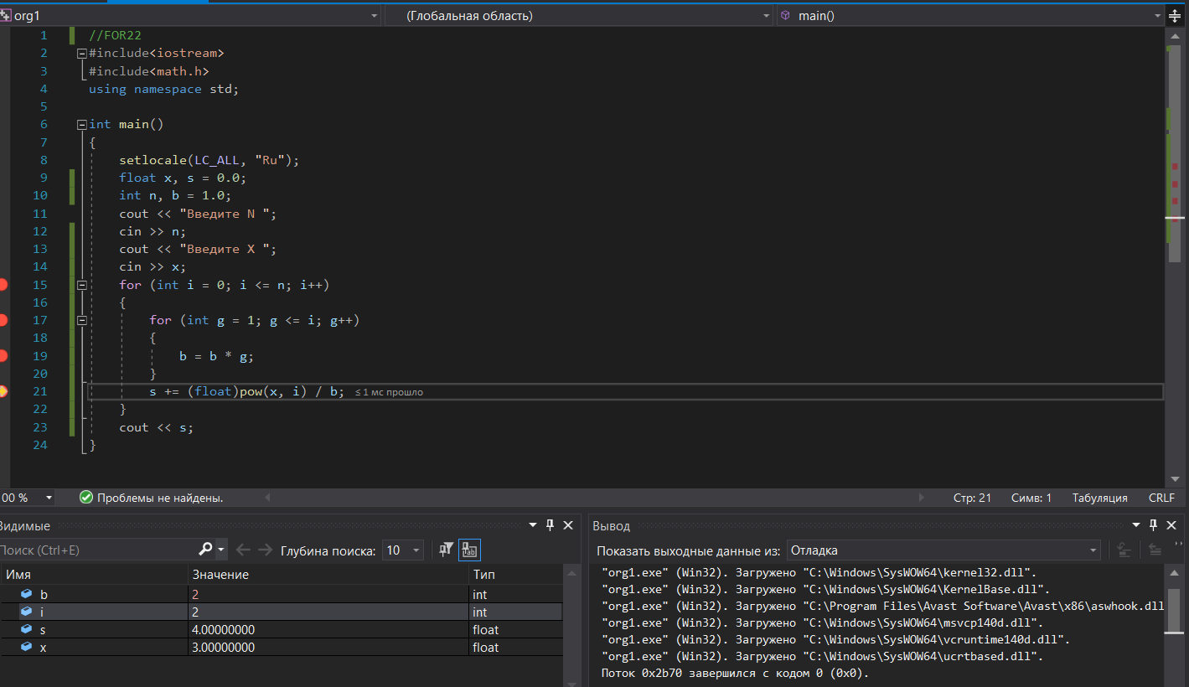

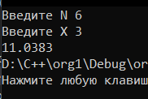 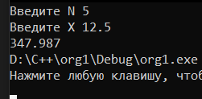

//FOR24

#include<iostream>

#include<math.h>

using namespace std;

int main()

{

setlocale(LC_ALL, "Ru");

float x, s = 0.0;

int n, b;

cout << "Введите N ";

cin >> n;

cout << "Введите X ";

cin >> x;

for (int i = 0; i <= n; i++)

{

b = 1.0;

for (int g = 1; g <= 2 * i; g++)

{

b = b * g;

}

s += pow(-1, i) * (float)pow(x, 2 * i) / b;

}

cout << s;

}

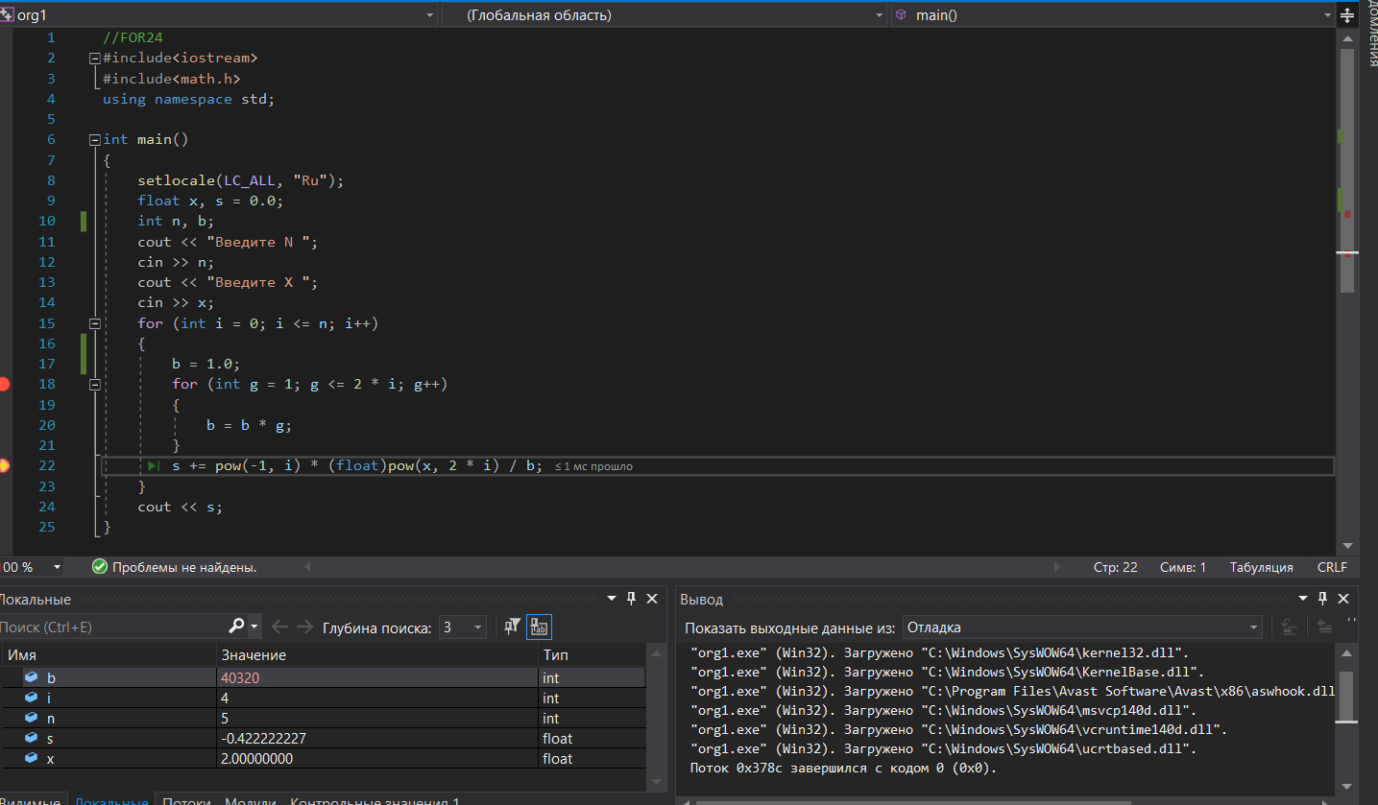

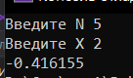

//FOR26

#include<iostream>

#include<math.h>

using namespace std;

int main()

{

setlocale(LC_ALL, "Ru");

float x, s = 0.0;

int n, b;

cout << "Введите N ";

cin >> n;

cout << "Введите X ";

cin >> x;

for (int i = 0; i <= n; i++)

{

s += pow(-1, i) * (float)pow(x, 2 * i + 1) / (2 * i + 1);

}

cout << s;

}

